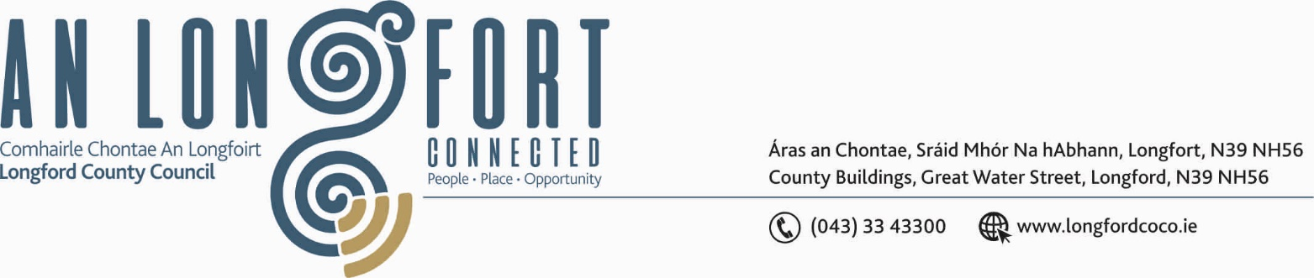

LONGFORD MUNICIPAL DISTRICT

18th July 2019.

To: Each Member of Longford Municipal District.

Dear Member,

You are requested to attend Meeting of Longford Municipal District to be held in the Council Chamber, Town Hall, Market Square, Longford, on Wednesday, 24th July 2019 at
4.30 p.m. to transact business, as set out on the Agenda hereunder.


Yours sincerely,

_______________
Anne Lee,
Meetings Administrator.

AGENDA

Prayer before meeting.

- Confirmation of the following Minutes of Longford Municipal District Meetings –
(a) Committee Meeting held on the 27th March 2019.
(b) March 2019 Municipal District Meeting held on the 27th March 2019.
(c) Annual Meeting held on the 17th June 2019.
- copies enclosed.

- Matters arising from Minutes.

- Declaration of Interest by Members.

- Management Report - to follow.

- Update on CCTV - report enclosed.

- Notices of Motions, submitted by Councillors, as listed hereunder -

Councillor John Browne.

“I call on Longford County Council to replace the pebble surface on the walkway around the Mall with a more suitable one, as older people, wheelchair users, and persons pushing prams, find it difficult to use”.

Councillor Martin Monaghan.

“I request that Longford Municipal District hold a monthly meeting once quarterly in
The Ralph Room, Newtownforbes.”

- Correspondence – enclosed.
(i) Correspondence received from the Neonatal Death Association of Ireland regarding “Wave of Light” on the 15th October.

- A.O.B.



